NAMES: HABINEZA Samuel

REG NO: 21RP01822

EMAIL: [habinezasamuel20@gmail.com](mailto:habinezasamuel20@gmail.com)

IPRC MUSANZE

**TOPIC: SMART WATERFLOW CONTROL AND MONITORING SYSTEM**

**Abstract:**

Water wastage is a worldwide issue. It needs constant monitoring to avoid water waste. One of the reasons for this is the public and administration are oblivious of what is going on. There are several types of water monitoring systems available, but they all require manual operation. The proper management of water is the focus of this project. The project's goal is to create a smart system for water discharge management and monitoring. The system is controlled and allows water to flow out of the pipe in a regulated manner. The quantity of water 'q' to be released and the time 't' to perform this duty must be input into the system and shown on the LCD screen coupled to Arduino at the transmitter end.

The data is delivered to the Arduino, which is located at the receiving end. The information obtained is compared to the code written in Arduino programming. The water flow sensor is connected to the arduino, and the needed amount of water is forced to flow through the pipe according to the code. The data is then sent to lcd where user can see the required details. This proposed system can effectively solve the problem of water discharge regulation.

**This project has successfully overcome the problem of control of water discharge.**

I.INTRODUCTION

Controlling water use is essential for maintaining life. Understanding household water usage may significantly improve water conservation. Even households might alter their spending patterns. There is an approaching worldwide water catastrophe, according to reports, caused by rapid population expansion, climate change, careless consumption, and persistent waste. The research gives a sombre assessment of the condition of freshwater on the world, particularly in emerging nations, and calls the prospects for future generations worrying. However, it takes time, is laborious, and necessitates that a family member be there to visually inspect each water tap in the house. We suggest a system that, whenever there is an odd reading of the water use at home, monitors and regulates the water flow through taps in order to accomplish this remotely. An interactive web-based solution called the Water Flow Monitoring and Controlling System can assist users in tracking daily water consumption and establishing water usage caps. The user may also set a cap on the water flow or volume.

This project is concerned with the efficient management of the water automatically.

This project can be used to measure liquid flowing through a pipe or container or to create a control system based on the water flow rate or quantity. For example, you could use this while gardening to measure the amount of water used to water your plants, to prevent wastage. Or you can use it to make [**Water Dispenser Machin**e](https://how2electronics.com/diy-water-filling-machine-using-flow-sensor-arduino/) used in industry and drinks items

Water Flow Sensor for Flow Rate & Volume Measurement using Arduino:

**COMPONENTS REQUIRED**

Arduino uno

Hall effect water flow sensor

16x2 LCD display

Potentiometer 10k

Connecting wires

Breadboard.

**APPLICATIONS**

* + - Water flow sensors can measure the rate of flow of water either by measuring velocity or displacement. These sensors can also measure the flow of water like fluids such as measuring milk in a dairy industry etc…
    - There are various types of water flow sensors available based on their diameter and method of measuring. A cost-effective and most commonly used water flow sensor is Paddlewheel sensor. It can be used with water-like fluids.
    - For the type of applications where a straight pipe is not available for inlet, Positive displacement flow meter is used. This type of water flow sensor can be used for viscous liquids also.
* For working with dirty water and wastewater which may be conductive, Magnetic flow meter is used. For applications such as sewage water, slurries, and other dirty liquids Ultrasonic flow meters are used.
  + - The LCD display is used to display the measurements. The magnetic hall effect water flow sensor outputs a pulse of every revolution of the rotor. The hall effect sensor present in the device is sealed from water to keep it safe and dry.

II.BLOCK DIAGRAM

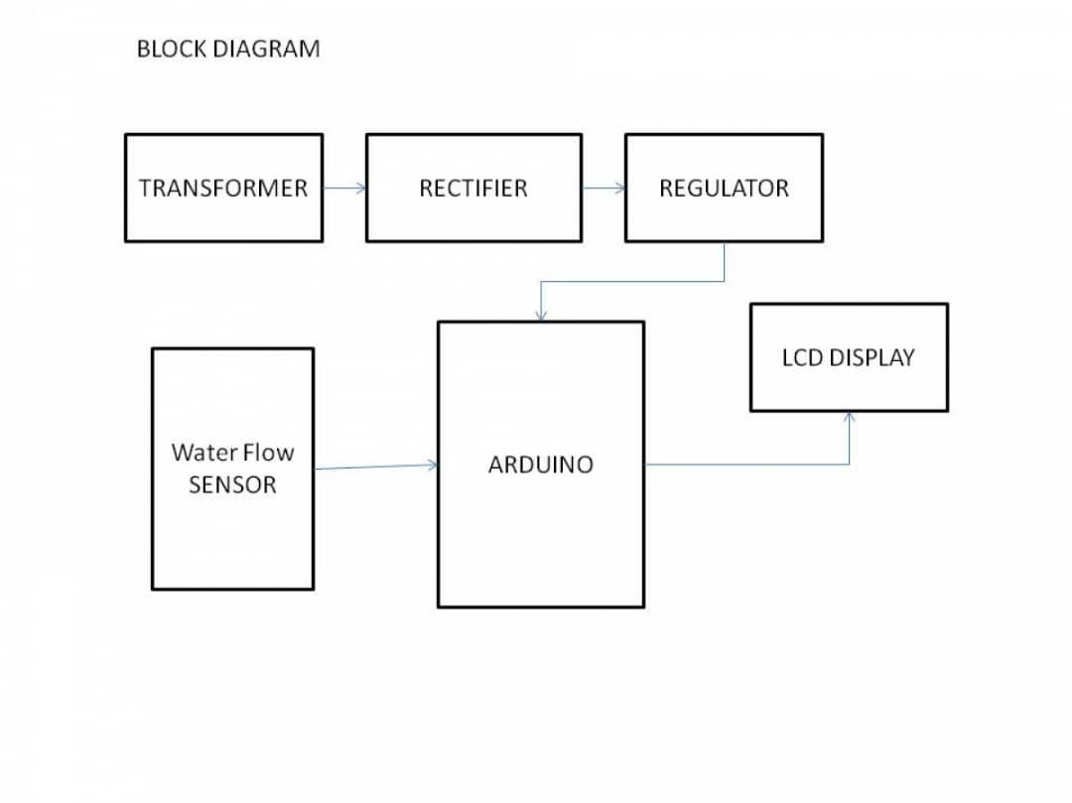

**2.TECHNOLOGY AND LITERATURE SURVEY**

The project Smart water flow control and monitoring system deals with the possible measure, monitoring and analysing the water flow. Brief description of the main components used in the project are given below

**2**.**1 Arduino**

The Arduino is an easy to use yet powerful single board computer that has guided considerable traction in the academic project and professional market. The Arduino is open-source, which means hardware is reasonably priced and development of software is free. The Arduino board can write programs and create interface circuits to read switches and other sensors, and to control different electrical components with very little effort. The board operates in 5V with 2 Kb of RAM, 32Kb of flash memory for storing programs and 1 Kb of EEPROM for storing parameters. The clock speed is 16 MHz, which translates to about executing about 300,000 lines of C source code per second. The board has 14 digital I/O pins and 6 analog input pins.

There is a USB connector for talking to the host computer and a DC power jack for connecting an external 6-20 V power source.

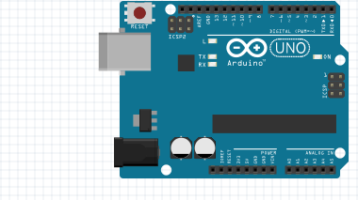

**2.4 LCD display (Liquid Crystal Display)**

A liquid-crystal display (LCD) is a flat panel display, electronic visual display, or video display that uses the light modulating properties of liquid crystals. Liquid crystals do not emit light directly.They use the same basic technology as seven segment display, except that arbitrary images are made up of a large number of small pixels, while other displays have larger elements.

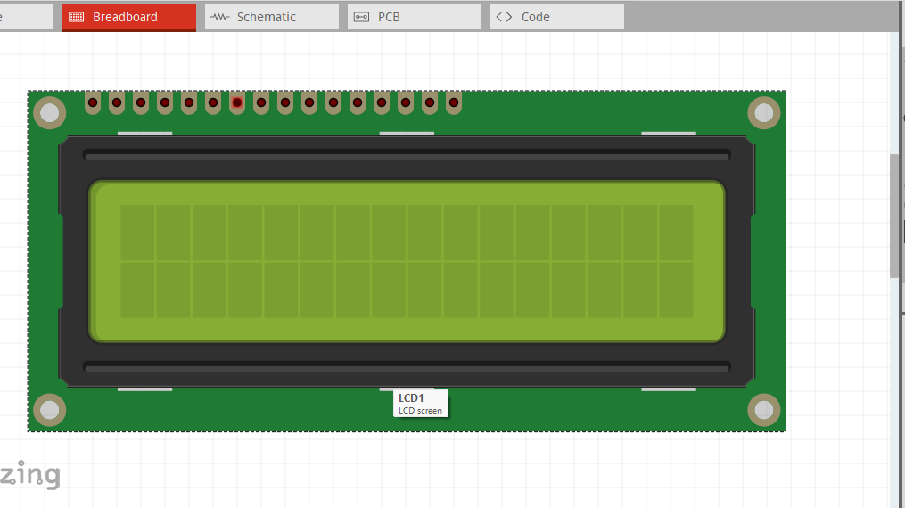

**Hall Effect Water Flow Sensor:**

Water flow sensor consists of a plastic valve from which water can pass. A water [rotor](https://en.wikipedia.org/wiki/Rotor) along with a hall effect sensor is present the sense and measure the water flow.

When water flows through the valve it rotates the rotor. By this, the change can be observed in the speed of the motor. This change is calculated as output as a pulse signal by the [hall effect sensor](https://www.elprocus.com/hall-effect-sensor-working-principle-and-applications/). Thus, the rate of flow of water can be measured.

The main working principle behind the working of this sensor is the Hall effect. According to this principle, in this sensor, a voltage difference is induced in the conductor due to the rotation of the rotor. This induced voltage difference is transverse to the electric current.

When the moving fan is rotated due to the flow of water, it rotates the rotor which induces the voltage. This induced voltage is measured by the hall effect sensor and displayed on the LCD display.

The water flow sensor can be used with hot waters, cold waters, warm waters, clean water, and dirty water also. These sensors are available in different diameters, with different flow rate ranges.

These sensors can be easily interfaced with microcontrollers like [Arduino](https://www.elprocus.com/arduino-basics-and-design/). For this, an Arduino microcontroller board for processing, a Hall effect water flow sensor, a 16×2 LCD display, and Breadboard connecting wires are required. The sensor is placed at the water source inlet or at the opening of the pipe.

The sensor contains three wires. Red wire to connect with supply voltage. Black wire to connect to ground and a yellow wire to collect output from Hall effect sensor. For supply voltage 5V to 18V of DC is required

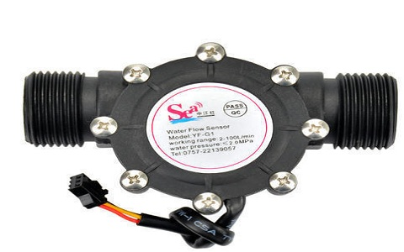

2.5 **breadboard**

A breadboard, solderless breadboard, or protoboard is a construction base used to build semi-permanent prototypes of electronic circuits. Unlike a perfboard or stripboard, breadboards do not require soldering or destruction of tracks and are hence reusable.

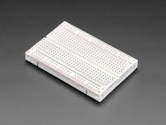

**2.6 jump wires**

A jumper wire is an electric wire that connects remote electric circuits used for printed circuit boards. By attaching a jumper wire on the circuit, it can be short-circuited and short-cut (jump) to the electric circuit.

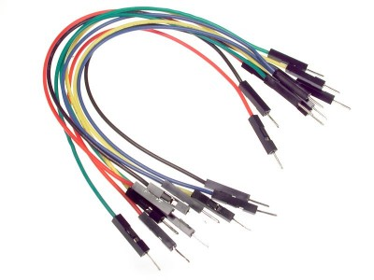

### ****Source Code/Program****

#include <LiquidCrystal.h>

LiquidCrystal lcd(7, 6, 5, 4, 3, 2);

**int** X;

**int** Y;

**float** TIME = 0;

**float** FREQUENCY = 0;

**float** WATER = 0;

**float** TOTAL = 0;

**float** LS = 0;

const **int** input = A0;

**void** setup()

{

Serial.begin(9600);

lcd.begin(16, 2);

lcd.clear();

lcd.setCursor(0,0);

lcd.print(“Water Flow Meter”);

lcd.setCursor(0,1);

lcd.print(“****************”);

delay(2000);

pinMode(input,INPUT);

}

**void** loop()

{

X = pulseIn(input, HIGH);

Y = pulseIn(input, LOW);

TIME = X + Y;

FREQUENCY = 1000000/TIME;

WATER = FREQUENCY/7.5;

LS = WATER/60;

**if**(FREQUENCY >= 0)

{

**if**(isinf(FREQUENCY))

{

lcd.clear();

lcd.setCursor(0,0);

lcd.print(“VOL. :0.00”);

lcd.setCursor(0,1);

lcd.print(“TOTAL:”);

lcd.print( TOTAL);

lcd.print(” L”);

}

**else**

{

TOTAL = TOTAL + LS;

Serial.println(FREQUENCY);

lcd.clear();

lcd.setCursor(0,0);

lcd.print(“VOL.: “);

lcd.print(WATER);

lcd.print(” L/M”);

lcd.setCursor(0,1);

lcd.print(“TOTAL:”);

lcd.print( TOTAL);

lcd.print(” L”);

}

}

delay(1000);

}

**3.CIRCUIT DIAGRAM**

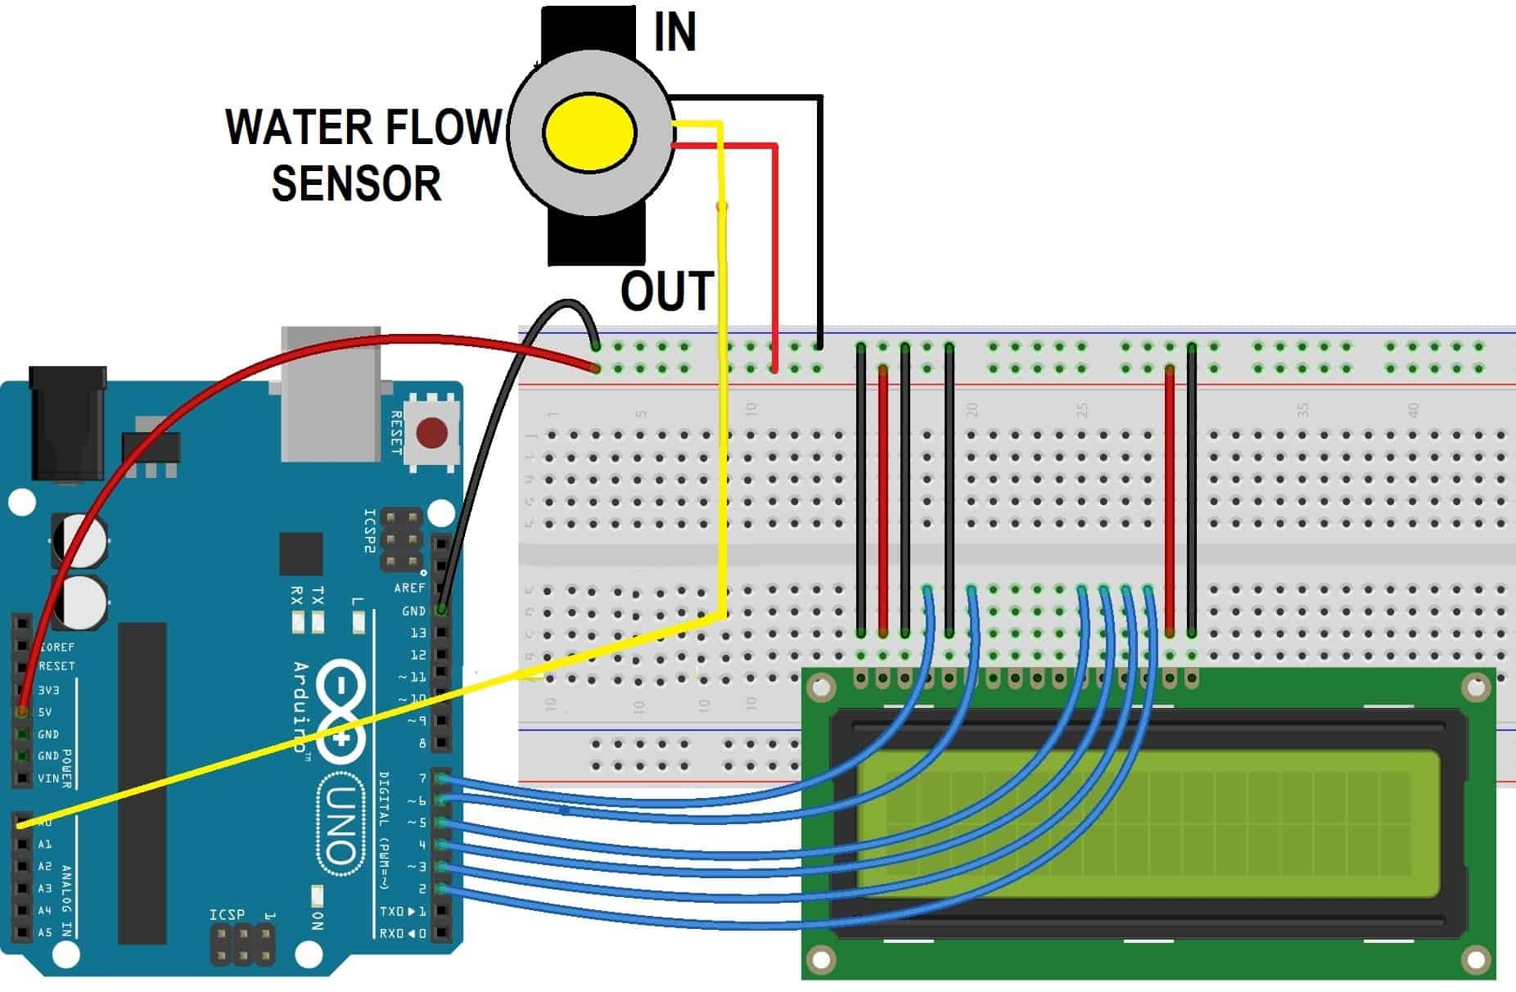

Connect the LCD pin 1, 3, 5, 16 to GND & 2, 15 to 5V VCC. And then connect LCD pins 4,6,11,12,13,14 to Arduino digital pins D7, D6, D5, D4, D3, D2.

Connect **Hall Effect Water Flow Sensor** VCC pins to 5V Power supply & GND to GND. Since it’s an analog sensor, so connect its analog pin to A0 of Arduino as shown in the figure above.

**5.WORKING AND DESCRIPTIONS**

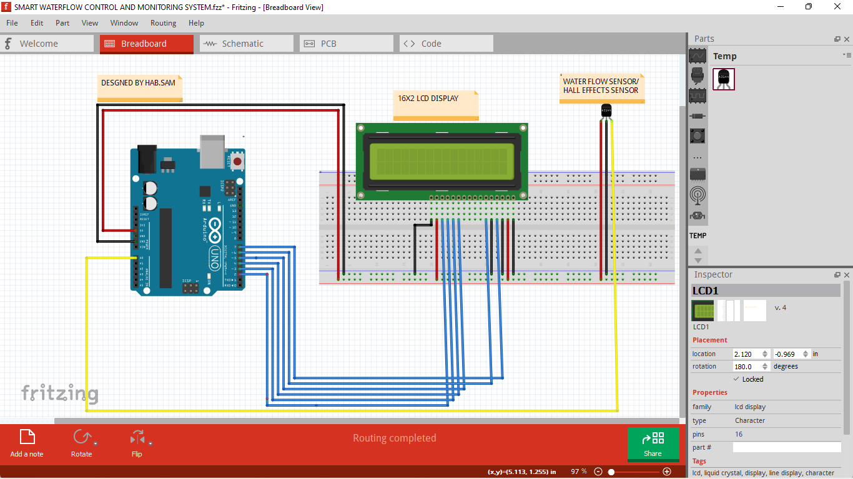

The data is delivered to the Arduino, which is located at the receiving end. The information obtained is compared to the code written in Arduino programming. The water flow sensor is connected to the arduino, and the needed amount of water is forced to flow through the pipe according to the code. The data is then sent to lcd where user can see the required details. This proposed system can effectively solve the problem of water discharge regulation

**5.2 Problems faced**

Followings were the problems faced during our project**:**

* Unavailability of components in lab.
* Unavailability of components in market at required time.
* Difficulty to get desired output during fabrication in breadboard.
* Difficulty in learning the programming languages for arduino.

**5.3 CONCLUSION**

This project has helped us to learn the practical aspects of the knowledge we gained so far through different courses. We would like to take this opportunity to thank our supervisor and our colleagues for all the help. The practical aspect of the theoretical component is learned along with the confidence to connect the complex circuit in the breadboard. We learnt a lot about the use of Arduino and its programming. The technical and practical field knowledge required in handling project is achieved. Furthermore, we learned to work in Group with different ideas and knowledge. Thus, working in this project has been an asset for us and we have been benefited from the experience gained during its completion.

This project is done by:

HABINEZA Samuel

Email: habinezasamuel20@gmail.com